**NoSQL : Column Family Database – HBase-1**

**Acccesed cs cluster and hbase below:**

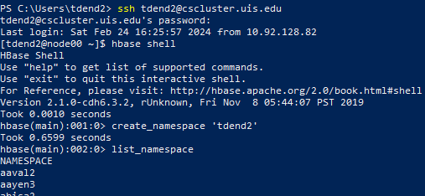

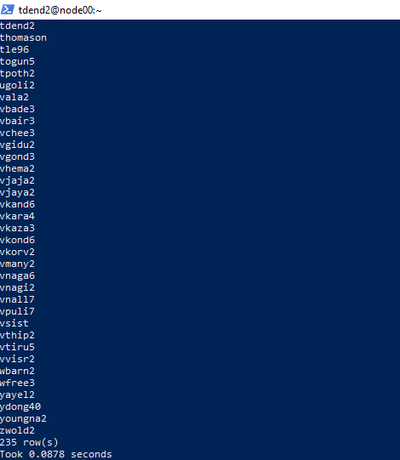

4.2. Data Definition Language (DDL) commands in HBase  
4.2.1. Namespace

4.2.2. Create a table

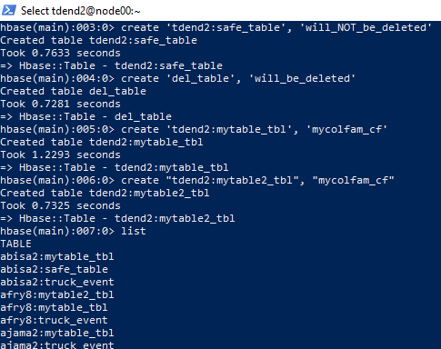

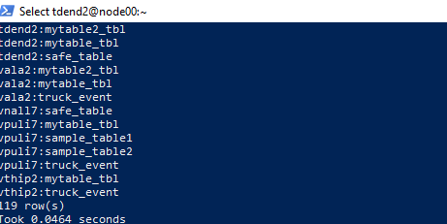

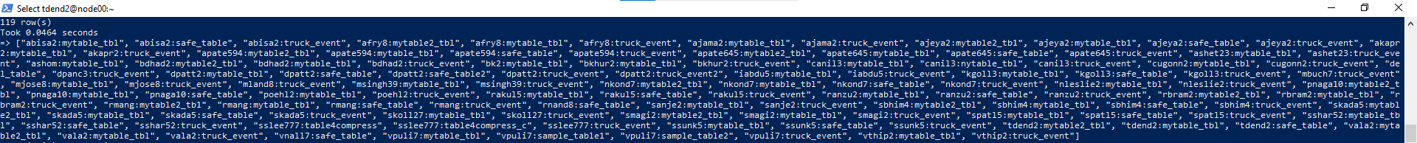

list_namespace_tables’. Only your tables under  
your namespace will show up.

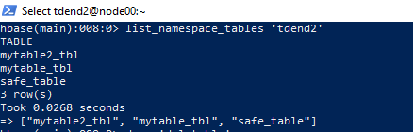

4.2.3. Delete tables

o delete/drop tables, use the drop command. But you need to disable the tables first.

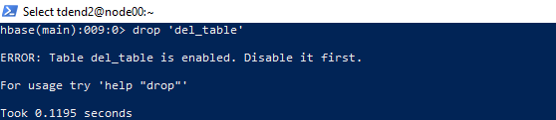

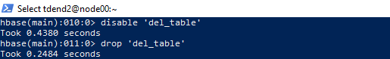

4.3. Data Manipulation Language (DML) commands in HBase  
4.3.1. Inserting and Reading Data: put and get/scan commands

Put, Get and Scan :

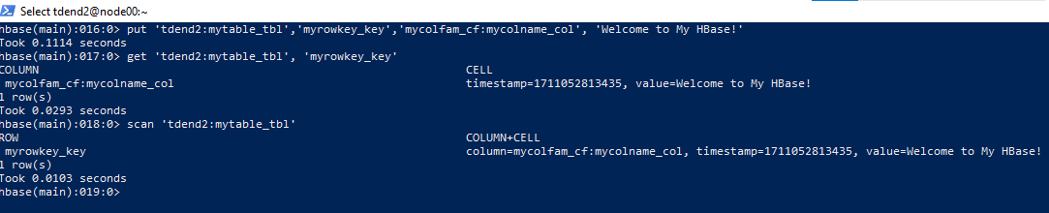

4.3.2. Loading data using the HBase utility  
Loading data from a CSV file using the HBase utility.

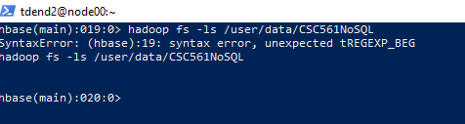

create 'tdend2:driver_dangerous_event', 'events'

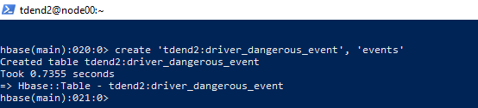

Import three-rows data into your HBase table.

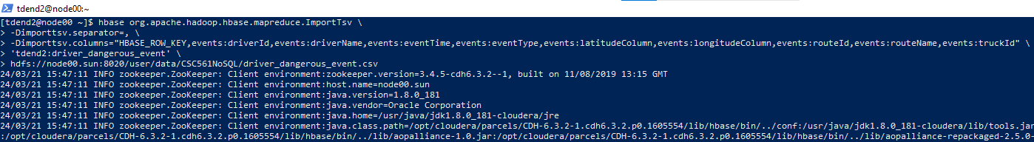

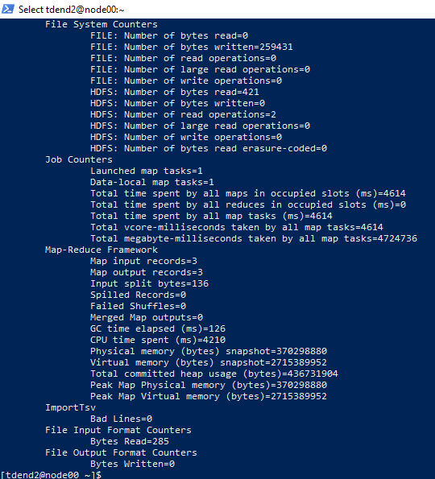

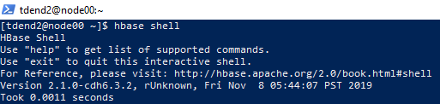

scan 'tdend2:driver_dangerous_event'

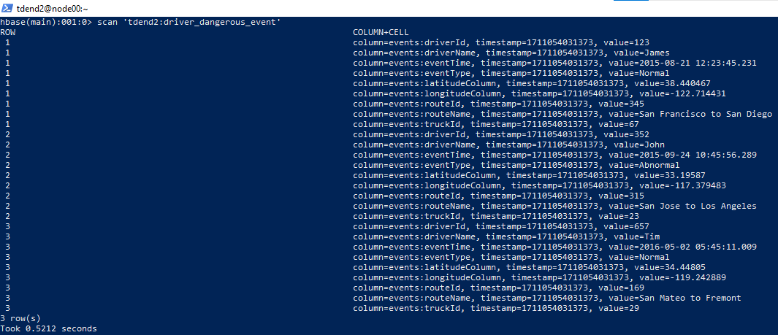

+++++++++++++++++++++++++++++++++++++THE END++++++++++++++++++++++++++++++++++++++++